**R Code for Examples in the book**

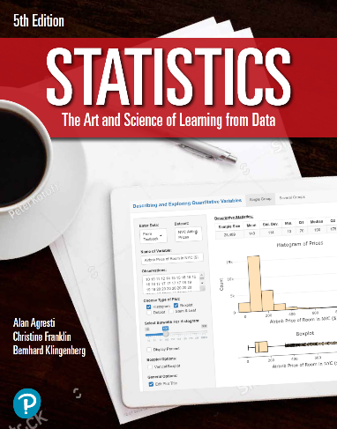

***“Statistics: The Art and Science of Learning from Data”***

**by Agresti, Franklin and Klingenberg, 5th edition**

**Chapter 10**

**Example 7: Standard Error for the Difference of Two Sample Means**

## Reading in data

effectiveness <- read.csv(file='https://raw.githubusercontent.com/artofstat/data/master/Chapter10/text_and_graph.csv')

## To subset data to make the two groups

textAndGraph <- subset(effectiveness, Graph == 'Yes')  
textOnly <- subset(effectiveness, Graph == 'No')

## To find sample mean, sample standard deviation, and sample size

sd1 <- sd(textAndGraph $Rating)  
sd2 <- sd(textOnly$Rating)  
n1 <- length(textAndGraph$Rating)  
n2 <- length(textOnly $Rating)

## To compute the standard error for the difference

se <- sqrt((sd1 ** 2 / n1) + (sd2 ** 2 / n2))  
round(se, 3)

## [1] 0.335